AI Agents Multi-Agent Design and Governance, Hands On1 - Integrate a Smart Agent
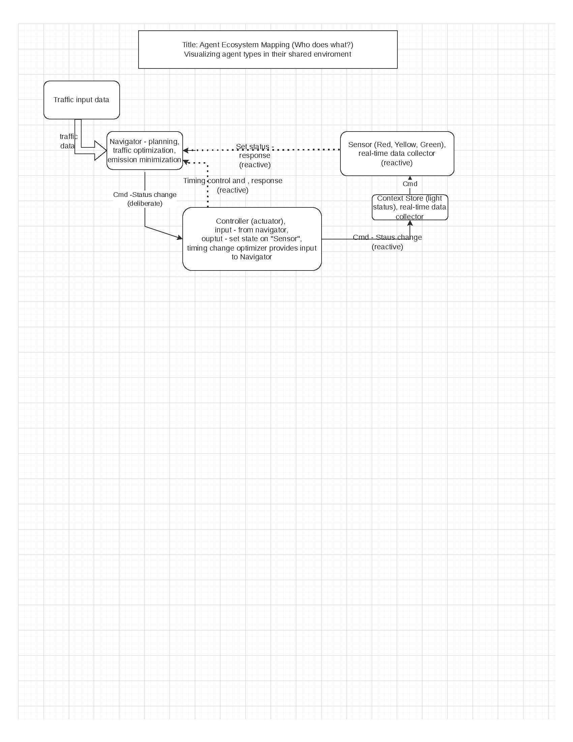
 | Agent Definition Table
 | Agent |  | Type |  | Justification
 | Sensor |  | Reactive |  | basic signal light that reponse to context store output
 | Controller |  | Reactive |  | input is from the Navigator, agent is reactive setting the  Sensor Store status
 | Navigator |  | Deliberate |  | provides planning and evaluated actions to optimize  traffic and minimize emissions
The smart intersection design is a hybrid multi-agent system composed of two reactive agents and one deliberative agent.
The Sensor Agent is reactive because it continuously collects real-time intersection and signal-state data. Since it is so simple this agents reliability and speed are excellent.
The Traffic Light Controller is also reactive because it immediately executes signal changes received from the planning layer. Speed and reliability are excellent.
The Route Planner, or Navigator Agent, is deliberative because it uses current traffic data and an internal model of the city’s road and signal network to evaluate alternatives and choose optimized actions. This is a complex agent, scalable, easily modifiable. Accuracy and system resilience could be degraded compared to reactive agents.
This classification matters because reactive agents provide fast, reliable local response, while the deliberative agent provides broader optimization for traffic flow, safety, and emissions reduction. Together, they create a system that is both responsive and intelligent.

